Newsletter – July 2026
learn,
laugh,
live

PRACTICAL
A message from your Chair
Here we are, halfway through the year already!! The schools are preparing for their summer holidays.

We are preparing for our 50th Wedding Anniversary party. Family and friends are joining us for what we hope is a happy reunion. All those years ago we had one week on honeymoon in Blackpool, we never thought we would one day live here in this beautiful part of Lancashire.

Are you going on holiday? Whatever you are doing, I hope you enjoy the summer break and see you in September.

Best wishes,
Shirley



Saunter Together Group
June 2026 Cleveleys to Bispham Sea Wall Defences Walk
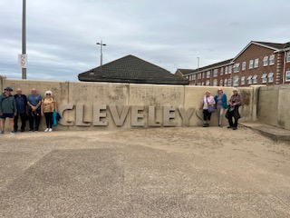
The Saunter Together group led by team member Jeff Darwell went further afield this month to Cleveleys on the coast. There were 7 of the team that walked along the sea defences from Cleveleys to Bispham and back. It was a flat 4 mile walk with a couple of slight inclines offering fantastic views of the Irish sea.
Although misty, the weather was kind to us again as we set out along the path to Bispham, the sea was out so we were able to see the old wreck of the ferry container Riverdance that ran aground all those years ago in January 2008 and we watched the construction work of the sea wall defences using extremely big boulders.
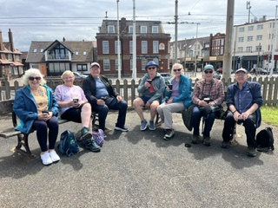
There was also a monument to all the boats that had been shipwrecked on the Fylde coast over the years.
The tram stop at Bispham was the half way stop where we stopped for light refreshments. On the return journey the sea had come in and the mist cleared so we had great views of Morecambe Bay and the Lakes in the distance.
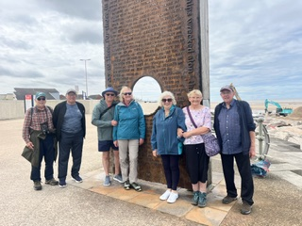
At the end of the walk, we indulged in fish and chips at the Cleveleys Kitchen. Well, it had to be done!
The July Walk will be along St Annes north beach to Star Gate and back.

Allan Williams

WINE TASTING GROUP
Our June wine tasting, hosted by member Alistair Bonham, explored the difference in taste between low and higher alcohol wines. Following a welcome glass of crémant we went on to taste two whites, two rosés and two reds, comparing the difference the alcohol content could make to the taste.
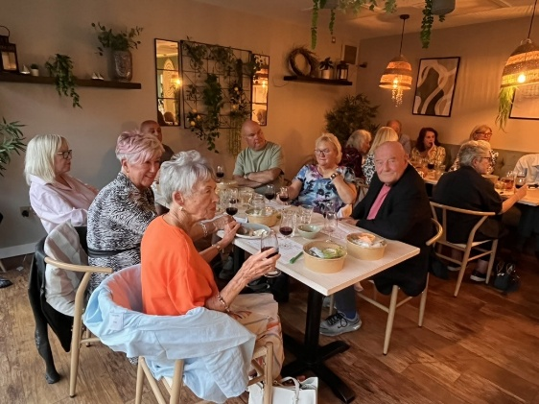
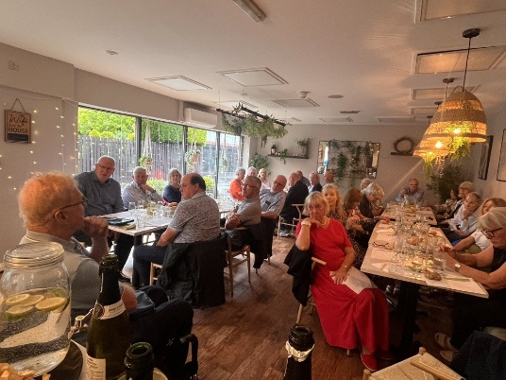
Alistair’s presentation was both entertaining and informative. We were told that in the 70s in the UK the annual consumption of wine was about 4-bottles per person, whereas in present time that is around 30 bottles per person.
The general trend in the UK has gone from the light and sweeter wines of the 70s to heavier more robust wines in following years and is once again trending towards lighter wines as our palates have matured and we have become more health conscious.

The wines we tasted were:
- Louis Couturier Cremant De Bordeaux
- Domaine Mallory et Benjamin Talmard, Mâcon-Villages 2024
- The Wine Society's Exhibition Limarí Chardonnay 2024
- Rezabal Txacoli Rosé, Getariako Txakolina, 2025
- Señorio de Sarrίa Rosado, Navarra 2025
- Morgon Côte du Py, Domaine Jean-Marc Burgaud 2024
- The Wine Society's Exhibition Barossa Shiraz 2024
A great selection, all from The Wine Society. As usual the event was held at the Fig & Olive in Lytham which provided us with a delightful venue and tasty snacks.
Next month – English wines!
Kathy Wykes

Poetry Group
We were a merry band of 9 bards this month and welcomed a new member, John. The theme was a poem based on a photo or object and we had a glorious diversity and range of responses. Barbara intrigued with an evocation of the 70s and going dancing as Gen X with flares, platforms and Tiger Feet. She then read us a version which she had asked AI to produce and the difference was so interesting- of course her own version had the nostalgia, craft and heart of a real poet. Lynda based a wonderful poem on the picture in the local Caffe Nero evoking a piazza in Italy and all the warmth of that country.
We were also treated to her Pam Ayres poem as four of us had so enjoyed that talented lady at the Lowther. We chuckled at her irreverent dig at having to do 100 lines for a teacher- thankfully a thing of the past. Newbie John treated us to a wealth of sewing vocabulary in his clever consideration of a spool of thread and this can be enjoyed below. He also wrote movingly about those who sacrificed themselves in WW1. Darryl wrote tenderly about the hopes and dreams of twin embryos just at the beginning of life. Mel wrote from the heart about a walking stick which had belonged to his late wife, the stick cherished and looked at often. He also treated us to how a special place had been destroyed by concrete and a memory of the fickleness of young love. Julian’s rich verses and glorious words embraced the endangered tusker elephant as well as a portrait of rock icons Robert Plant and Stevie Nicks. The ever-self-effacing Margaret transported us to beautiful Islay with an experience of shops in a phone booth, cakes in a box and the restful silence of island life. She showed her clever use of structure when describing awakening toads. Definitely a place to visit and Margaret’s growth as a talented poet delights. Alan took us to Fountains Abbey as well as the grace and fecundity of an apple tree; he can take any subject at all and transform it with rhythm and rhyme. Jacky described her dysfunctional family ever preserved in sepia and explained the challenges of OCD.
The next meeting is Thursday 9th July from 2-4pm at the Well Centre St Albans Rd as usual. Cost £3 for hall hire. The theme is shopping – either a poem inspired by a shopping receipt or more broadly the whole concept of shopping whether it be in person or on-line- funny or serious- your own work or sourced from another poet. All welcome. There are no hard and fast rules and you could even just bring along your favourite poems on any subject to read and enjoy. All welcome. All appreciated.

Jacky Ramage

Poetry Group
Article of the month!
A Tailor of Two Cities
I like a reel, but cannot dance
My best friend is a small steel lance
In and out and round I go
I’m a proper sew and sew

With every unexpected rip and tear
Look around, you’ll find me there
Unlike a camel, an eye is no bar
When I’m with a Singer, I travel quite far
Some people say that I tell a good yarn
And though it’s a story, I mean no one harm
So don’t take offence at the things I have said
But listen more carefully and follow the thread
Of the words I have spoken, I know there’s a lot
But being upset, I hope you are knot
Bobbin and weaving’s just something I do
Not trying to deceive, or appear untrue
Though sometimes not straight, I’m often quite nimble
And when I’m at work, you might need a thimble
By now I’m sure that you’ve cottoned on
And know who I am, the mystery gone
I’d pinned my hopes on holding out further
But it’s time to go, I heard someone murmur
So, I’ll cut and run, but to cushion the blow
I’ll wind up this neatly and then I will go
John Fisher

BIRD WATCH GROUP
Leighton Moss RSPB 9th June 2026
Dodging between the showers from hide to hide we had a number of good sightings. Highlights were Bittern in flight, Hobby, Marsh Harriers, Tree Creepers, Avocets and Spoonbills.
Full list was:
Great Crested Grebe, Little Grebe, Cormorant, Bittern, Grey Heron, Little Egret, Great White Egret, Spoonbill, Mute Swan, Canada Goose, Greylag Goose, Common Shelduck, Gadwall, Mallard, Tufted Duck, Coot, Moorhen, Red-breasted Merganser, Marsh Harrier, Hobby, Oystercatcher, Black-tailed Godwit, Avocet, Greenshank, Redshank, Black-headed Gull, Greater Black-backed Gull, Woodpigeon, Swallow, Sand Martin, House Martin, Swift, Pied Wagtail, Robin, Blackbird, Robin, Blackcap, Reed Warbler, Cetti’s Warbler, Blue Tit, Great Tit, Marsh Tit, Long-tailed Tit, Bearded Tit (Reedling), Treecreeper, Magpie, Jackdaw, Goldfinch.
Other wildlife – distant Otter.
Due to holidays, we have decided to go for 7th July as our next meeting date, venue will be Mere Sand Wood.
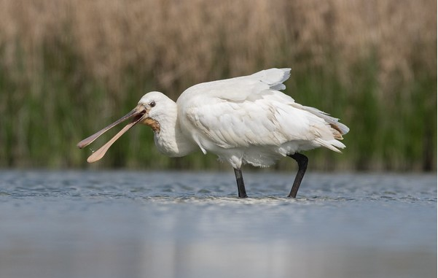

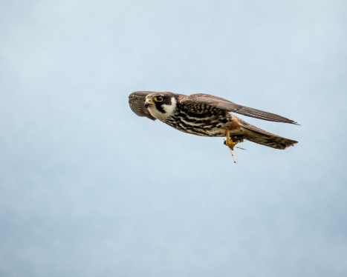

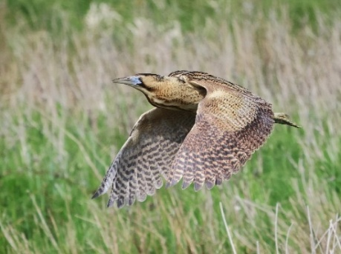
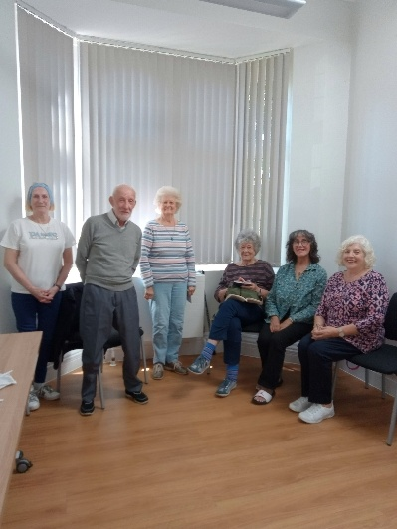
Play Reading Group
We had a great session this afternoon, despite not having a full complement of readers.
The play was a farce by Ray Cooney, Two into One.
Our next session is on Wednesday 15th July.
No session in August, back to normal September.

Irene Tucker
Bridge Group
The Bridge Group continues to meet at 1.30 on Thursday afternoons at The District Club in St Annes. We are a small but friendly group playing relaxed Bridge. New members welcome. A partner is not essential but a knowledge of ACOL required. Help is always at hand with bidding if needed. Tea, coffee and biscuits provided in the break. Cost £2 table money.

Marjorie Short

Eating Out Group
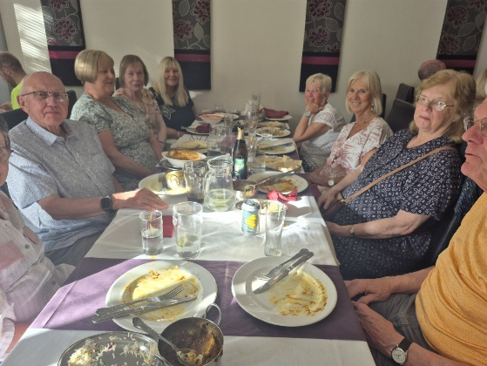
The eating out group met on Wednesday 24th June at the Imli Indian restaurant, Wood Street in St Annes. There were 10 members in attendance. Several fixed price early bird options were on the menu, consisting of poppadums with chutney a starter, followed by a choice of curries. The quality of the food and drink at Imli is excellent as is the service.
The next evening meal out will be on Wednesday 22nd July and we will meet at Zen Thai/Chinese restaurant in Wood Street in St Annes at 5:30pm.

Donald Mobbs
BOOK GROUP 2
Reading Aloud!/Allowed!
Vacancies have arisen in the above Book Group; would you like to join us? We meet every 3rd Tuesday in the month at 2.15 pm for about an hour at The Fairhaven Pub., Ansdell/Fairhaven. Please give me a ring 01253 780439 if you would like more information or would like to join us.
Margaret Mayor
Gardening Group
Too hot to garden!
Our June meeting was gazebo based (!) and the weather sizzled. Cold drinks helped us focus on a design challenge. Most gardeners are on the lookout for ways to add new dimension, new features, structural modifications to their plot.
Could we suggest ways to create a tempting journey, hide a view, reveal a view, disguise an outbuilding, add height, make a back border zing with winter interest? The final question had an interesting twist - how to make a garden easier to manage when our advancing years make it harder to bend, lift, stretch, mow etc.
Good teamwork threw up some well thought out designs.
Want some help with your own plot?
We have 2 vacancies in our membership - just contact Martin Lammas and we'll be happy to welcome you.
We are an established group with considerable experience, both individually and collectively.
And before refreshments were served, our monthly quiz brought new pointers, the raffle added to vital funds and the plant swap underscored what all enthusiastic gardeners love to do - share and learn.

Martin Lammas
History Group
Our June meeting was held on a very hot afternoon during the heatwave. Despite the weather enough members came along to join in our discussion, ‘From the wheel to AI’, looking at how technical and scientific advances had affected human history. Interesting points were raised and we agreed in every era new developments were met with suspicion and resistance.
As we sat in the heat, we pondered on the effect of burning fossil fuels since the industrial revolution on life today and wondered what the age of artificial intelligence had in store for future generations. We enjoyed a lively discussion to which all members contributed.
Our next meeting is on Wednesday July 22nd at 2pm at the Drive Methodist Church (please note this is 4th Wednesday not the last of the month). Jenny Butcher will follow up her previous talk ‘When Cotton was King’ with a presentation entitled ‘King Cotton in Decline’. This traces the history of the Lancashire cotton industry from the late Victorian era to the 1960’s. Jenny’s interest in this subject is due to the fact that she was born and brought up in Bolton.

Jenny Butcher

Transport History Group
We are very pleased with progress, and our second meeting on June 25th went well. We were entertained by Debbie Morris who gave a rundown of her somewhat unique experiences in competitive motorsport. Specifically, the field of hill-climbing – normally thought of as an all-male domain – clearly not by Debbie!
The remaining three talks of our initial programme are scheduled as follows:
Date | Speaker/Subject
July 23rd | Gary Thornton - "The Beginnings of Powered flight"
August 27th | Chris Holley – The V22 “Osprey” – Aeroplane or Helicopter?
September 24th | Gordon Day – Little Imps

We are already planning for talks to carry on through the winter months and are in negotiations for the continuing use of the venue. Watch This space!
Our meetings commence at 10.30 with refreshments and the talk of the commences at about 10.45 lasting about 50 minutes. Our venue is the Community Room of the Drive Methodist Church, 268 Clifton Drive South, Lytham Saint Annes FY8 1LH
If you missed us last time, our aim is to have regular meetings, with a speaker, covering any transport related subject. The deliberate intention is to keep the subject matter wide and thus including anything transport related, on land sea or air, old and new.
If you have a favourite transport related subject you’d like to talk about to a like-minded audience – now is your opportunity! Contact us on our dedicated email transporthistorygroupu3a@gmail.com if you would like to know more. We very much look forward to meeting friends old and new!

Peter Skinner & Chris Holley

Walking Group - Cuerdon Valley

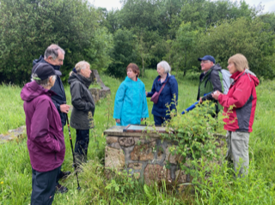
Not even the threat of heavy downpours and even thunderstorms was enough to deter eight brave souls clad in waterproofs from meeting in the pub car park. Indeed, the walk both started and ended with us following Richard’s blue brolly - but each time only for a few minutes. As the clouds parted and the sun came out, for the next two hours we tramped across moorland and woodland, getting held up by sheep crossing our path. Richard had certainly done his homework, taking us to the site of a former linen mill hidden away deep in the woods before leading us to the top of the hill with magnificent views overlooking Buckshaw Village. Here he explained that the village was built on the site of the former royal ordnance factory and the hill we were standing on had hidden underground bunkers for storing ammunition. After the recent rain, flora and fauna were out in full. We took our time gazing at swifts and skylarks, admiring the displays of elderflower, dog roses and other wild plants. 5.5 miles later we were back at the pub and ready to sit down to a very welcome lunch. As always, many thanks Richard for another great walk.
Linda Nugent


Wine Lovers Unite
Perfect for experienced wine lovers and those who would like to learn more. Our qualified tutor provides a fun-filled day learning all about the art of wine-making; understanding the role of the grape variety, climate, techniques and the soil – plus pairing food with wine to suit personal taste. We also include a visit to Ryedale Vineyard, a family-owned business, for a tour and tasting.
Arrival on 23 May 2027, departing 27 May 2027
Your hotel is The Old Swan, Harrogate
Prices: 3 nights £569 per person sharing a twin or double room
Board: Dinner, bed & full English breakfast, plus one light lunch

For more information, click here Wine Lovers Unite

We’re looking for your help

GROUPS CO-0RDINATOR
In order for our very successful Group to continue functioning, we need someone to take over this important role from Jan Breame who has to step down in September of this year.

In this role you will:

#Liaise with Group Leaders
Provide support and act as the main point of contact for Group Leaders

#Help set new Groups
Guide and support through the process of creating new Groups

#Publish new Groups
And any vacancies in existing Groups

#Hold a Group Leaders Meeting
once a year and attend monthly Committee Meetings

Your help will grow our vibrant community by supporting Group Leaders and making it easy for new Groups and opportunities to thrive.

Every Group starts with support
Can YOU be that support?

If you would like to discuss this opportunity, please contact Jan Breame on 07472 189750 or email her at janbreame@hotmail.com.

NEW MEMBERS



Andy Atamaniuk Barbara Atamaniuk Marguerite Comber Judith Davitt John Slinger Catherine Prescott Jacqueline Smith John Longstaff John Newick Linda Timms John Fisher Neil Turner

Our policies and other useful information can be viewed on our website on the News and Info page. Press here to access the information.

SPEAKER PROGRAMME 2026

Our Speaker Meetings are open to all Members and are held on the second Friday of each month (except August) at St. Anne's United Reform Church Hall, St George's Road, St Anne's, Lancashire, FY8 2AE. Members gather from 10.00 hours for coffee and chat with friends, old and new and the opportunity to find out about the different interest and social groups that are available. At 10:30 hours we spend a few minutes on general u3a news before sitting back and enjoying a talk or entertainment that usually ends by 12.00 hours.

Our 2026 speaker programme is as follows:

July 10 | My Life at Granada TV; Judy A Popley
September 11 | The Assassination of John Lennon; Peter Mellor
October 9 | Photos Tell Stories – the stories behind famous photographs; Jackie Mafi
November 13 | Wives, Workers & Widows of the Great War; Jennifer Ray
December 11 | Festive Music; Yvonne Pinder

CONTACT INFORMATION

Our website: | https://lytham-st-annes.u3asite.uk
Northwest u3a website | https://northwestregion.u3asite.uk
National u3a website | www.u3a.org.uk
Chair | Shirley Dickson lsau3achair@outlook.com
Newsletter Editor | Susan Hodgson hodgy50@yahoo.co.uk
Membership Secretary | Ian Dickson lsau3amemsec@gmail.com
Beacon Manager | Mike Ripley beacon.lsa.u3a@gmail.com
Groups Co-ordinator | Jan Breame janbreame@hotmail.com
Speaker Secretary | Norma Sands sands.23@outlook.com
Website | Phil Huddleston pdh_mail-U3A@yahoo.com
u3a Lytham St. Annes is a registered charity: 1013058

